EXPT. NO: 8 | ONE DIMENSIONAL ARRAY
DATE:22.1.2020 | ONE DIMENSIONAL ARRAY
Aim:
To write a C program for the following to
- Perform linear search
- Sort the given numbers using bubble sort
- Populate an array with height of persons and find how many persons are above the average height.
1. Linear search
Algorithm
Step 1: Set found to 0 And pos = -1
Step 2: Print "Enter the number of elements in the array:"
Step 3: GET n
Step 4: Set i to 0
Step 5: if i < n then go to step 8
Step 6: GET arr[i]
Step 7: Set i to i + 1 and go to step 5
Step 8: Print "Enter the number that has to be searched: "
Step 9: GET num
Step 10: Set i to 0
Step 11: if i < n then go to step 16
Step 12: if a[i] == num
Step 13: Set found to 1 And pos = i
Step 14: num is found in the array at position = i
Step 15: Set i to i + 1 and go to step 11
Step 16: if found == 0
Step 17: num does not exist in the array
Step 18: Exit

Flowchart
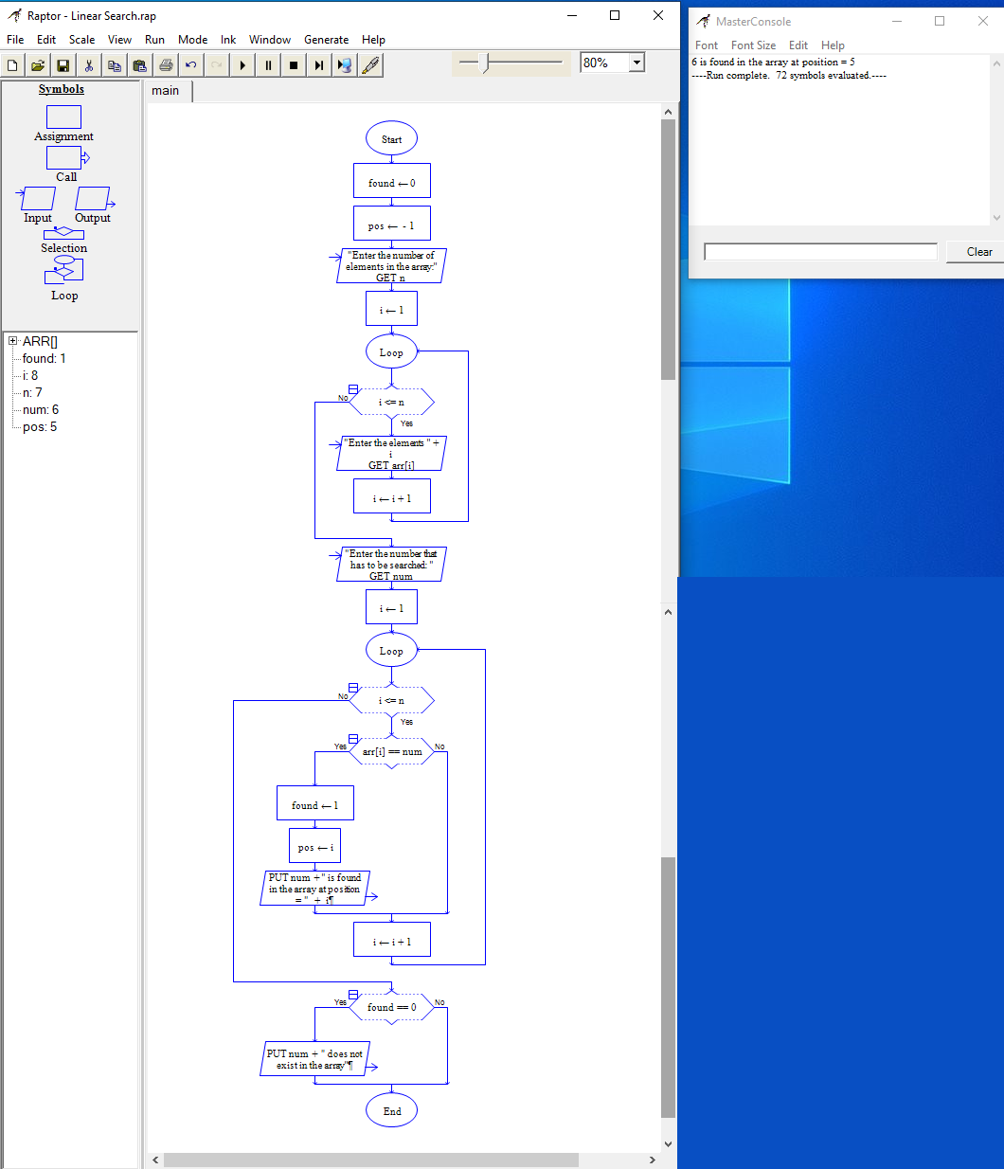
Program
#include<stdio.h>
int main(){
int arr[10], num, i, n, found = 0, pos = -1;
printf("\nEnter the number of elements in the array: ");
scanf("%d",&n);
for(i = 0; i < n; i++) {
printf("\nEnter the elements %d: ",i+1);
scanf("%d",&arr[i]);
}
printf("\nEnter the number that has to be searched: ");
scanf("%d",&num);
for(i = 0; i < n; i++) {
if(arr[i] == num) {
found = 1;
pos = i;
printf("\n %d is found in the array at position = %d", num, i);
break;
}
}
if(found==0) {
printf("\n %d does not exist in the array", num);
}
return 0;
}
Output
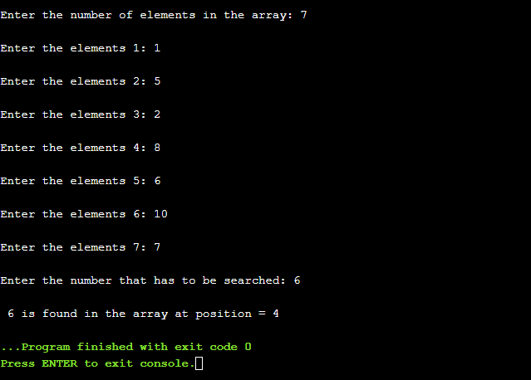
2. Bubble sort
Algorithm
- GET Number Of Elements
- GET array[i]
- for i = 0 i < n – 1 then
- for j = 0 j < n - i – 1 then
- if array[i] > array[i + 1] then
- temp = array[j]
- array[j] = array[j+1]
- array[j+1] = temp
- Exit

Flowchart
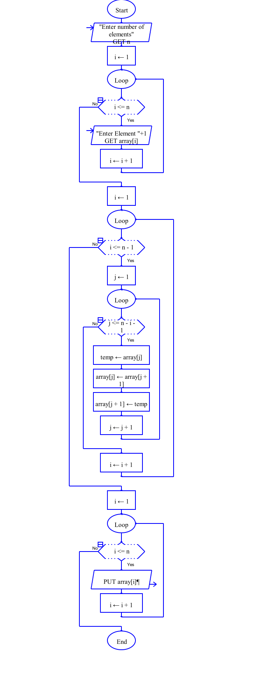
Program
#include <stdio.h>
int main()
{
int array[100], n, i, j, temp;
printf("Enter number of elements\n");
scanf("%d", &n);
printf("Enter %d integers\n", n);
for (i = 0; i < n; i++) {
scanf("%d", &array[i]);
}
for (i = 0 ; i < n - 1; i++) {
for (j = 0 ; j < n - i - 1; j++) {
if (array[j] > array[j+1]) {
temp = array[j];
array[j] = array[j+1];
array[j+1] = temp;
}
}
}
printf("Sorted list in ascending order:\n");
for (i = 0; i < n; i++) {
printf("%d\n", array[i]);
}
return 0;
}
Output
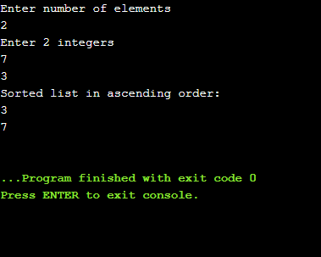
3. Populate an array with height of persons and find how many persons are above the average height
Algorithm
- GET Number Of Elements as n
- GET array[i]
- for i = 0 i < n then
- avg += array[i]
- for i = 0 i < n then
- IF array[i] > avg
- Array[i]
- Exit
Flowchart
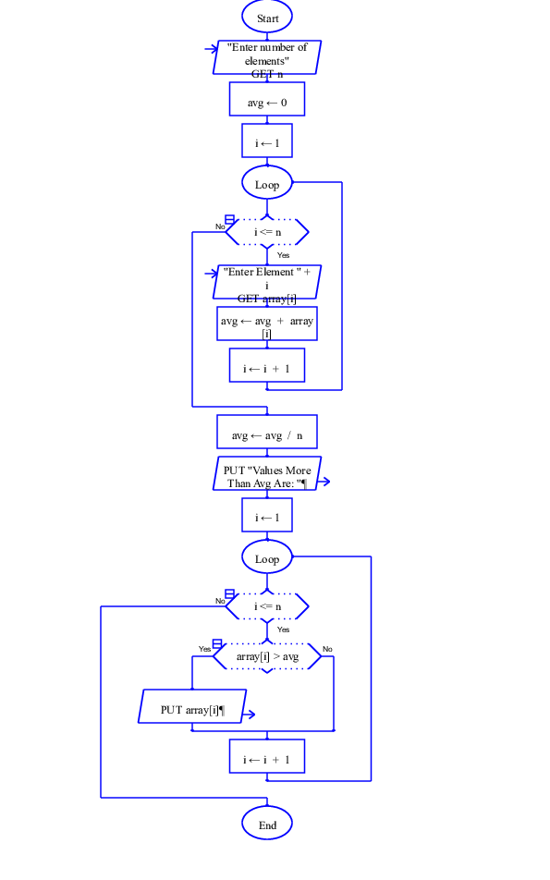
Program
#include <stdio.h>
int main()
{
int array[100], i, n;
float avg = 0;
printf("Enter number of elements\n");
scanf("%d", &n);
printf("Enter %d integers\n", n);
for (i = 0; i < n; i++) {
scanf("%d", &array[i]);
avg += array[i];
}
avg = avg / n;
printf("Values More Than Avg Are: ");
for (int i = 0; i < n; i++)
if (array[i] > avg)
printf("%d, ", array[i]);
return 0;
}
Output
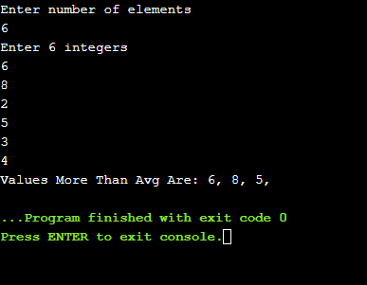
Result
Thus the C program was written and executed successfully for the following
- Perform linear search
- Sort the given numbers using bubble sort
- Populate an array with height of persons and find how many persons are above the average height.

